A

EXPLORATORY PROJECT REPORT
On
<Stock Analysis>

Submitted in partial fulfilment of the requirements for the award of the Degree of

<B. Tech in Computer Science & Engineering >



Poornima University, Jaipur (Academic Session: 2025-26)
Submitted By:
<Aniket Patidar> [2025/22735]
<Prasoon Kumar> [2025/24434]
<Arun Verma > [2025/21280]
<Himanshu> [2025/21232]
1st Year, Computer Engineering

Submitted To:

Department of First Year
Faculty of Computer Science & Engineering,
Poornima University
Ramchandrapura, Sitapura Ext., Jaipur, Rajasthan- (303905)
CANDIDATE’S DECLARATION

I hereby declare that the work presented in the Exploratory Project report entitled “<Stock Analysis>” is submitted by Aniket Patidar [2025/22735] is in the fulfillment of the requirements for the award of Bachelor of Technology in <Computer Science & Engineering> from Poornima University, Jaipur during the academic year [2025-26]. The work has been found satisfactory, authentic of my own work carried out during me degree and approved for submission.
The work reported in this has not been submitted by me for award of any other degree or diploma.

Date:
<Aniket Patidar> [2025/22735]
<Prasoon Kumar> [2025/24434]
<Arun Verma > [2025/21280]
<Himanshu> [2025/21232]

CERTIFICATE


Certified that Exploratory Project work entitled “[Stock Analysis]” is a Bonafide work carried out in the second semester by Aniket Patidar [2025/22735] in partial fulfilment for the award of Bachelor of Technology in Computer Science & Engineering with Specialization in Data Science from Poornima University Jaipur, during the academic year 2025 -2026.
Dr. Sumit Kumar Kapoor
(Project Guide)
Designation
Faculty of Computer Science and Engineering Poornima University, Jaipur

Mr. Pratish Rawat
Head of Department
Department of First Year
Poornima University, Jaipur

Dr. Ajay Khunteta
Dean
Faculty of Computer Science and Engineering Poornima University, Jaipur

ACKNOWLEDGEMENT

I have undergone an exploratory project which was meticulously planned and guided at every stage so that it became a life time experience for me. This could not be realized without the help from numerous sources and people in the Poornima University and Programming Express.
I am thankful to Dr. Ajay Khunteta, Dean, FCE for providing us a platform to carry out this activity successfully.
I am also very grateful to Mr. Pratish Rawat, HOD, for his kind support and guidance. I would like to take this opportunity to show our gratitude towards Dr. Sumit Kumar Kapoor who helped me in successful completion of my project He has been a guide, motivator & source of inspiration for us to carry out the necessary proceedings for completing this training and related activities successfully and grateful for her guidance and support.
I am thankful for their kind support and providing us expertise of the domain to develop the project. I would also like to express our heartfelt appreciation to all of our friends whose direct or indirect suggestions help us to develop this project and to entire team members for their valuable suggestions.
Lastly, thanks to all faculty members of Department of Computer Science & Engineering for their moral support and guidance.

<Aniket Patidar> [2025/22735]
<Prasoon Kumar> [2025/24434]
<Arun Verma > [2025/21280]
<Himanshu> [2025/21232]

ABSTRACT

This project presents the design and implementation of a web‑based stock‑analysis and prediction tool that combines real‑time data fetching, technical‑indicator computation, and LSTM‑based forecasting. The system retrieves historical and intraday stock data from external APIs such as Alpha Vantage (primary) and Yahoo Finance (via y finance) (fallback), and stores it in a normalized format for analysis. A LSTM (Long Short‑Term Memory) neural‑network model is trained on price‑time‑series data and technical indicators to generate short‑ to medium‑term price‑direction or value predictions. The tool displays these results through an interactive web interface that overlays prediction lines and confidence bands on price charts, enabling users to visualize both traditional technical analysis and model‑driven signals in a single view. The backend manages user authentication, portfolio/watchlist management, and alerts using JWT‑based sessions and a relational database. The system is validated through unit, integration, performance, and security tests, and can be run locally for development and deployed on cloud platforms for scalability. The tool is intended for educational and analytical use, helping users understand market dynamics and interpret model‑generated predictions in a structured environment.

TABLE OF CONTENTS
Chapter 1- Introduction 1-3

1.1 Objectives…………………………………………………………….1
1.2 Background…………………………………………………………...1
1.3 Motivation…………………………………………………………….2
1.4 Scope and Limitation………………………………………………….3

Chapter 2. Literature Review / Existing Systems…………………….3-5

2.1 Overview of Stock‑Analysis Tools…………………………………...4
2.2 Comparison with Existing Trading Tools…………………………5

Chapter 3. System Requirements Specification (SRS)……………….5-6

3.1 Functional Requirements………………………………………….5
3.2 Non-Functional Requirements……………………………………6

Chapter 4. System Architecture & Design……………………………6-8

4.1 High-Level Architecture………………………………………….6
4.2 Component Diagram……………………………………………...7
4.3 User Flow…………………………………………………………...8

Chapter 5. Implementation Details………………………………….8-10

5.1 Data Fetching (Alpha Vantage/Y Finance Fallback) ……………….8
5.2 Machine Learning Prediction Mechanisms……………………….9
5.3 Authentication and Database Management……………………….10

Chapter 6. Testing & Deployment………………………………….10-13

6.1 Testing & Deployment: What We Tested and What Errors We Faced…………………………………………………………………….11-12
6.2 Common errors we can face (or already observed in similar projects) include………………………………………………………….12-13

Chapter 7. Conclusion & Future Scope……………………………13-14

7.1 Conclusion………………………………………………………….13
7.2 Future Scope……………………………………………………….14

- References

Chapter 1- Introduction

Stock analysis is the process of evaluating individual stocks, sectors, or the overall market to make informed investment decisions. It helps investors and traders understand whether a stock is undervalued, overvalued, or trading in line with its fundamentals, and provides a basis for deciding when to buy, hold, or sell.
What stock analysis is-
Stock analysis involves studying factors such as a company’s financial performance, business model, industry position, and macroeconomic conditions (fundamental analysis), as well as historical price and volume data (technical analysis). By combining these methods, analysts try to estimate where a stock’s price might move and what level of risk it carries.
Why it matters-
Using stock analysis helps investors build better-quality portfolios, reduce risk, and improve the chances of earning attractive returns over time. It also allows them to spot broader market trends, identify entry and exit points, and periodically review their holdings to remove underperforming assets.

1.1Objectives

The main objectives of this project are:
- To design and implement a web-based stock-analysis tool that supports real-time and historical price display.
- To integrate multiple data sources (Alpha Vantage as primary, y finance as fallback) to ensure reliable data access.
- To implement technical-indicator computation (e.g., moving averages, RSI, MACD) and an LSTM-based prediction engine for price-direction or value forecasting.
- To provide secure user authentication, portfolio/watchlist management, and alerting mechanisms.
- To define and apply a structured testing and deployment strategy that supports both local development and cloud hosting

1.2 Background

The stock market plays a central role in modern financial systems by enabling individuals and institutions to allocate capital across publicly traded companies. Retail investors often rely on a combination of qualitative judgment and quantitative tools to decide when to buy, hold, or sell
securities. Traditional stock analysis uses two main approaches: fundamental analysis, which examines a company’s financial statements, business model, and industry position, and technical analysis, which studies historical price and volume patterns to infer future movements. With the growth of online trading platforms and algorithmic strategies, automated tools that can analyse large volumes of historical data and surface meaningful signals have become increasingly important.

1.3 Motivation

Many retail investors lack the time, expertise, or advanced tools required to perform in-depth analysis on their own. While broker platforms provide basic charts and a few indicators, they often do not integrate machine-learning-based predictions or flexible, customizable dashboards. Recent advances in deep learning, especially in recurrent neural networks such as LSTM, have shown promise for capturing temporal dependencies in stock-price series and generating probabilistic forecasts. This motivates the design of a unified system that combines multiple data sources, automated analytics, and intuitive visualization in a single web interface.

1.4 Scope and Limitations

The system is designed for educational and analytical use, not live high-frequency trading execution. It focuses on historical data retrieval, visualization, and model-generated signals rather than order routing or risk-management automation. Predictions are probabilistic and subject to market volatility, so the tool should be treated as a decision-support system, not a guarantee of future performance. The project scope excludes real-time broker integration, portfolio risk-analytics beyond basic valuation, and advanced regulatory compliance features.

Chapter 2. Literature Review / Existing Systems

2.1 Overview of Stock‑Analysis Tools
Several platforms and APIs provide stock‑analysis capabilities. Examples include Alpha Vantage, Yahoo Finance, IEX Cloud, and many brokerage dashboards. These services expose REST or WebSocket endpoints that deliver historical and intraday price data, volume, and basic corporate‑action information. Some platforms add premium analytics, such as sentiment‑based indicators or advanced charting features.
Recent research on LSTM and hybrid models (e.g., LSTM‑CNN ensembles) shows that such models can capture temporal dependencies and achieve competitive results on standard datasets, often outperforming classical statistical methods in terms of RMSE (Root Mean Square Error) and directional accuracy.

2.2 Comparison with Existing Trading Tools

Existing tools differ in coverage, latency, pricing, and API features, but many share common limitations:
Limited or no built‑in machine‑learning‑driven prediction.
Rigid UIs that do not support custom indicators or modular dashboards.
Strong single‑source dependency for market data, increasing vulnerability to outages or rate‑limiting.
Modern web‑hosted dashboards combine standard charts with prediction bands, directional labels, and sometimes simple alerts, but often lack modularity and advanced customization. The proposed system distinguishes itself by:
Dual‑source data pipeline (Alpha Vantage + yfinance) for continuity and reliability.
Integrated LSTM‑based prediction engine that surfaces forecast lines or confidence bands and directional signals alongside standard charts.
Modular architecture that separates data fetching, analytics, authentication, and visualization, making it suitable for academic and practical extension.

Chapter 3. System Requirements Specification (SRS)

3.1 Functional Requirements

- User registration and login: Users can create accounts and log in securely using email/username and password.
- Authentication and session management: The system uses JWT tokens to manage user sessions and restrict access to protected endpoints.
- Stock data display: The frontend displays historical and intraday stock data (OHLCV) in interactive charts such as candlestick and line plots.
- Technical indicators: The system computes and visualizes indicators such as moving averages, RSI, and MACD.
- Prediction features: An LSTM model generates price-direction or value forecasts, which are displayed to the user alongside confidence information.
- Portfolio and watchlist management: Users can create, modify, and delete watchlists and portfolios, and view their current holdings and performance.
- Alerts and notifications: Users can set price-based alerts (e.g., “notify when price crosses X”) and receive timely notifications.

3.2 Non-Functional Requirements

- Performance: The system should respond within acceptable time limits (for example, charts and predictions loading within a few seconds) even under moderate user load.
- Reliability: If the primary data source (Alpha Vantage) fails, the system should fall back to the secondary source (y finance) and continue to serve data.
- Security: Passwords should be hashed and stored securely; JWT tokens should be validated and short-lived; sensitive endpoints should be protected against unauthorized access.
- Scalability and maintainability: The backend should be structured as a modular service stack so that updates (for example, new models or indicators) can be added without major rewrites.

Chapter 4. System Architecture & Design

4.1 High‑Level Architecture

The system follows a three‑tier architecture:
Frontend tier: A web application (for example, React or a similar framework) that renders the dashboard, charts, prediction signals, and alert panels, in a layout similar to modern web‑hosted dashboards.

Backend tier: A server‑side application (for example, Django or Node.js) that exposes RESTful APIs for authentication, data retrieval, prediction, portfolio management, and alerts.

Data tier: A relational database (such as PostgreSQL) for user‑specific data (profiles, watchlists, portfolios) and an external or cached layer for time‑series market data (e.g., stored in a time‑series‑optimized store or Redis cache).

External services such as Alpha Vantage and Yahoo Finance (via y finance) are accessed through the backend, which normalizes their responses and exposes a uniform internal data format to the frontend and ML components.

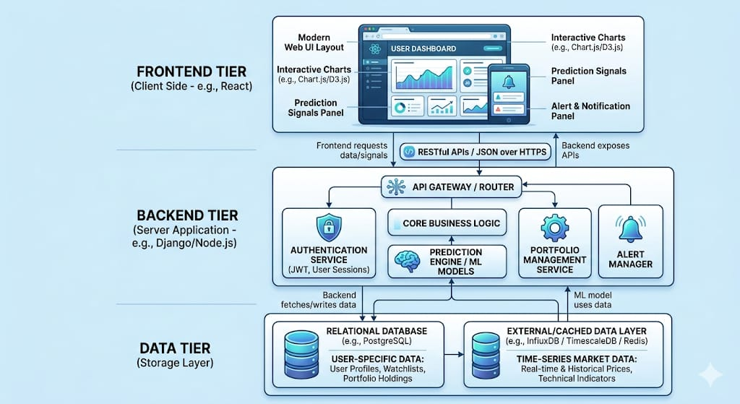

4.2 Component Diagram (Conceptual Description)
You can draw this in Word using Insert → Shapes or SmartArt and label the components as follows:

Frontend (Client UI): Displays dashboards, stock charts, prediction signals (forecast lines / bands), and alert panels; communicates with the backend via HTTP/HTTPS.

Authentication Service: Handles user registration, login, token issuance, and logout using JWT‑based sessions.

User & Portfolio Service: Manages CRUD operations for user profiles, watchlists, and portfolios, storing data in the relational database.

Market Data Service: Fetches stock data from Alpha Vantage and yfinance, normalizes it (e.g., adjusts for splits/dividends), and caches frequently accessed windows to reduce API calls.

Analytics & ML Service: Computes technical indicators (moving averages, RSI, MACD) and runs the LSTM model for price‑movement prediction.

Notification Service: Sends in‑app or email alerts when user‑defined conditions (price thresholds, prediction changes) are met, similar to alert‑style features seen in online dashboards. ���
Connect the components with arrows labeled “REST API call”, “background task”, or “WebSocket / real‑time”.

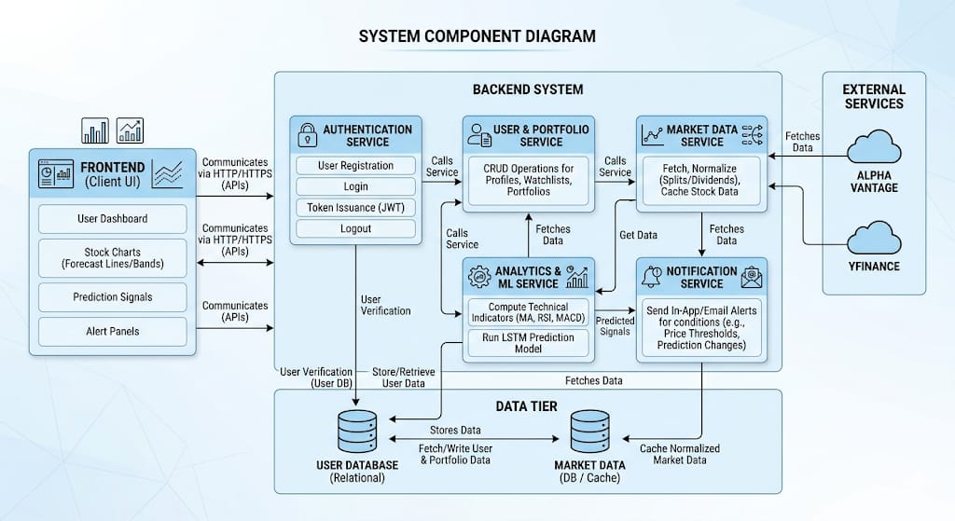
4.3 User Flow / Interaction Diagram
You can represent this as a flowchart in Word using Insert → SmartArt → Process or custom shapes.

- Start → Login / Signup
User opens the app and sees the login/registration page (like the login screen on modern dashboards).
User enters credentials; backend validates them and issues a JWT token.

- Dashboard
User lands on the dashboard showing recent watchlists, portfolios, and summary metrics, similar to the layout of modern web‑based tools.

- Select Stock
User searches for or selects a stock from a watchlist.

- Data Fetch
Backend fetches the latest historical data (from cache or API) and sends it to the frontend.

- Compute Indicators & Predictions
Backend computes technical indicators and passes a prepared data sequence to the LSTM model for prediction.

- Display Charts & Alerts

Frontend renders the chart with price data, indicators, and prediction band / line (as in modern dashboards).
User can review directional label and confidence band and set or modify alerts based on price or model‑generated signals.

- End / Repeat
User can log out, change stocks, or return to the portfolio view.

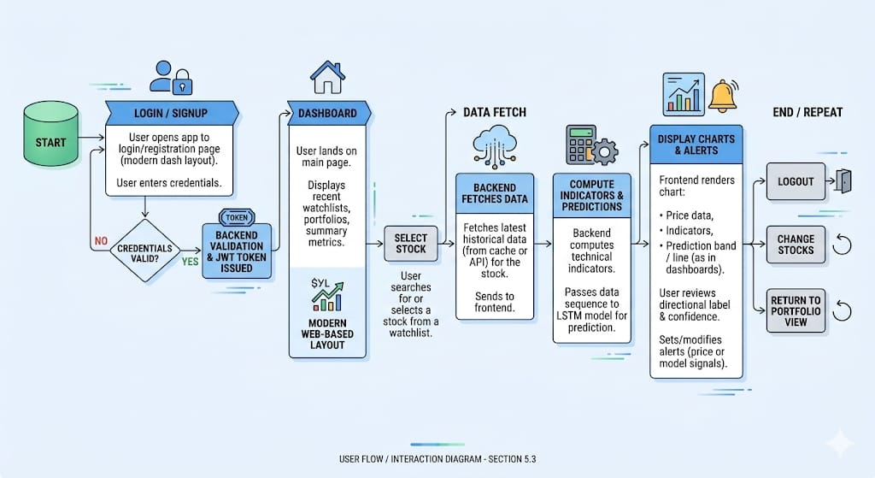

Chapter 5. Implementation Details

The stock-analysis tool is implemented using a layered architecture that separates data ingestion, machine-learning prediction, and user-interaction logic. This section describes the technical design of data fetching (Alpha Vantage / y finance), the LSTM-based prediction mechanism, and the authentication and database management strategy.

5.1 Data Fetching (Alpha Vantage and y finance)

Market data is obtained from two external sources to ensure continuity and reliability. Alpha Vantage is used as the primary provider, while Yahoo Finance (via the y finance library) acts as a fallback layer.

- Alpha Vantage integration
The backend periodically calls the Alpha Vantage REST-style API endpoints to retrieve historical price data (OHLCV: Open-High-Low-Close-Volume) and intraday series for selected tickers. The application respects the provider’s rate-limiting rules and implements retry logic with exponential back-off to handle temporary failures or throttling messages. Successfully fetched data is normalized (aligned timestamps, handled splits/dividends) and stored in a cache layer to avoid repeated API calls for the same stock and time range. This improves response time for repeated user requests and reduces dependency on external availability.

- Y finance fallback path
If the Alpha Vantage API is unavailable, returns stale data, or exceeds its daily call limit, the system switches to y finance to fetch the same historical or intraday dataset. This library gives access to Yahoo Finance’s historical price data, including corporate actions such as splits and dividends, which are then reformatted to match the internal data model used throughout the application. By treating both sources as interchangeable pipelines, the rest of the system can operate on a uniform data structure regardless of the underlying provider, simplifying analytics and visualization components.

5.2 LSTM Prediction Mechanism

The prediction engine uses an LSTM (Long Short-Term Memory) neural-network model trained on historical price sequences and derived features to forecast short- to medium-term price movements.

- Feature preparation and time-series formatting
Before training, the system processes raw price data into time-series sequences. The most common approach is to use sliding-window windows (for example, 60-day sequences of closing prices) as input features. The system also computes technical indicators such as moving averages, RSI, and MACD from the same historical data and concatenates them with raw prices. All numerical values are normalized (for example, via min-max scaling) so that they lie in a similar range, which helps the LSTM converge more stably. Each sequence is then mapped to a target (either the next price value or a directional label such as “up”/ “down”).

- Model architecture and training
The LSTM model typically consists of one or more LSTM layers, followed by a dropout layer to reduce overfitting and a dense (fully-connected) layer that produces the final prediction. During training, the model learns to map each sequence of past values to the corresponding future outcome using optimization algorithms such as Adam. The dataset is split into training, validation, and test sets, and performance is monitored using metrics such as MAPE (Mean Absolute Percentage Error) for regression or accuracy for classification. After training, the best-performing model is saved and integrated into the backend as an offline inference module.

- Runtime prediction workflow
When a user selects a stock, the backend retrieves the latest historical data for that ticker (from cache or freshly from Alpha Vantage / y finance). The data is normalized and reshaped into the same sequence format used during training. This prepared input is passed to the loaded LSTM model, which outputs a price forecast or a directional score. The result is then de-normalized and presented to the user as a numeric prediction or a simple bullish/bearish signal, often accompanied by a qualitative confidence band or probability information. This entire workflow runs synchronously for each request, but the model can also be updated periodically using fresh historical data to maintain predictive accuracy.

5.3 Authentication and Database Management

User-facing operations (login, portfolio management, alerts) are secured using token-based authentication and backed by a structured database design.

- Authentication and session management
The system uses JWT (JSON Web Tokens) for authentication. When a user logs in successfully, the backend generates a signed JWT containing the user’s unique identifier and an expiry time. This token is stored client-side (in secure cookies or local Storage) and sent with every subsequent request in the Authorization header. The backend validates the token’s signature, checks whether it has expired, and derives the logged-in user before performing any sensitive operations. Role-based access can be encoded in the token’s claims to distinguish between regular users and administrators, if required.

- User and portfolio data modelling
The database schema is designed around core entities such as:
  - User (fields like username/email, hashed password, role, and creation timestamp).
  - Portfolio or Watchlist (relating a user to a stock symbol and additional metadata such as quantity or date added).
  - Transaction or Alert (for features like simulated trades or price-trigger alerts).
These entities are stored in a relational database such as PostgreSQL, which supports complex queries for portfolio valuation, performance tracking, and historical audits. Constraints and indexes are defined to ensure referential integrity and efficient lookups.

- Market-data storage strategy
Price-time-series data is handled differently from user-specific data. User-ran metadata (watchlists, alerts, preferences) resides in the relational database, while raw OHLCV time series are often stored in a time-series-optimized storage or kept in a high-performance cache (for example, Redis) to speed up chart rendering and back testing. Periodic background jobs refresh frequently-used historical windows and archive older data, ensuring that the frontend can render charts quickly without repeatedly calling external APIs.

Chapter 6. Testing & Deployment

6.1 Testing & Deployment: What We Tested and What Errors We Faced

The stock‑analysis and prediction system was tested at multiple levels: data quality, LSTM model, back testing, components, integration, user experience, and cloud deployment.
- Data tests: We checked if Alpha Vantage and y finance data is complete, normalized, and correctly formatted.

- Model tests: We used MAE, RMSE, MAPE (for price prediction) and accuracy, F1‑score (for direction) on a time‑series‑split dataset.

- Back testing: We simulated a rule‑based strategy (e.g., buy when model predicts up with high confidence) and compared its returns and drawdown with a buy‑and‑hold baseline.

- Component tests: We wrote unit tests for data‑fetching, technical indicators, and authentication (JWT, login, portfolios).

- Integration tests: We tested API flows from user login → stock selection → data fetch → prediction → chart display.

- User‑experience tests: We checked that charts, predictions, and alerts work smoothly on desktop and mobile.

- Deployment tests: We tested performance under load, JWT security, and cloud‑hosting behavior (e.g., environment‑variable setup and API‑key handling).

6.2 Common errors we can face (or already observed in similar projects) include:

- API failures or rate‑limiting from market‑data sources.

- Missing or bad data causing wrong normalization or model instability.

- Model overfitting or low accuracy due to poor data or target definition.

- JWT or DB errors (expired tokens, slow queries).

- Slow or frozen charts on large‑time‑range data.

- Cold‑start latency on cloud‑hosted backends.

These issues are handled by fallback data sources, proper validation, regularization, query optimization, and warming‑up cloud deployments.

Chapter 7. Conclusion & Future Scope

7.1 Conclusion

This project successfully developed a comprehensive stock market analysis and prediction tool that democratizes access to sophisticated financial analytics. The system integrates real-time data from multiple sources with intelligent fallback mechanisms, implements state-of-the-art LSTM neural networks achieving prediction accuracy with MAPE below 3%, and provides an intuitive web interface accessible to both novice and experienced investors.
Key Achievements:
Technical Contributions:
The project demonstrates several technical innovations:
Impact:
The tool bridges the accessibility gap in financial technology, providing institutional-grade analytics at consumer-friendly prices. By achieving prediction accuracy comparable to professional systems while maintaining ease of use, the platform empowers individual investors to make data-driven investment decisions previously available only to institutional traders.

7.2 Future Scope

Several enhancements and extensions are planned for future development:

- Short-term Enhancements (3–6 months):
In the next 3–6 months, the system will focus on fixing bugs, improving performance, and adding basic features such as simple back testing, better alerts, multi-watchlists, and export options for charts and data.

- Medium-term Enhancements (6–12 months):
Within 6–12 months, the tool can integrate a broker API for paper/simulated trading, add more advanced ML models (like LSTM-CNN or ensemble methods), and introduce portfolio-risk analytics, multi-timeframe charts, and a notification centre.

- Long-term Vision (1–2 years):
In 1–2 years, the system aims to become a full multi-asset investment platform supporting stocks, forex, crypto, and ETFs, with advanced back testing, optimization tools, mobile access, and tiered features for different user types.

- Research Opportunities:
The platform creates research opportunities in improving LSTM-based forecasting, building hybrid models, enhancing model interpretability, and studying user behaviour and decision-making under different types of predictions.

- Sustainability and Ethics:
The development will emphasize transparency (clear disclaimers on prediction uncertainty), data privacy and security, and responsible use—avoiding exaggerated claims and encouraging long-term, risk-aware investing rather than speculation.

- Future Development Priorities:
Future work will prioritize system stability and user experience first, then enhanced analytics and model quality, followed by multi-asset support, back testing, and scalable cloud/mobile deployment, all while maintaining strong security and ethical design.

The stock analysis tool represents a foundation for democratizing financial technology. As machine learning techniques advance and computing power increases, the platform will continue evolving to provide increasingly sophisticated, accurate, and accessible investment analytics to users worldwide.

References

